A Question.
How do we do this?
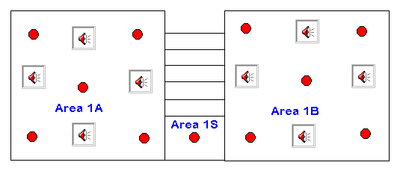
Cause and Effects
Area 1A goes into evac on a (double knock basis) if any two of the detectors in area 1A or Area 1S (combined) activate.
Area 1B goes into evac on a (double knock basis) if any two of the detectors in area 1B or Area 1S (combined) activate.

